SQL Assignment
Hotel Reservation

Group members:-
R.A.U.S Ranaweera HD 91109 I.C Rathnayaka HD 91110E.M.N.L.EkanayakeHD 91033

HDCBIS 2009.1
National Institute of Business Management
HDCBIS 2009.1

Contents

Summary 2

ER Diagram 3

Relational Model 4

Database Architecture 7

Final Set of Tables 9

Specification of Stored Procedures 20

Appendix Stored Procedures 35

Specification of Triggers 21

Appendix Triggers 38

Specification of Views & Joins 22

Appendix Views & Joins 40

Specification of Built in Functions 24

Appendix Built in Functions 40

Security Plan 26

Appendix Security Plan 40

Appendix Database Creation 28

Appendix Table creation 30

Conclusion 43

Summary

Hotel Reservation

- All rooms have numbers. Room can be a Suit, Cabana, Deluxe or Standard room, but all the rooms contain a Room Number. Some rooms contain a name, but it is not considered as the unique identification of that room. Unique identification for all the rooms will be the Room Number.

- All rooms must have a bathroom, and one room has only one bathroom.

- One guest can reserve more than one room in one reservation. But one room can be reserved only by one guest at one time.

- One guest can receive more than one invoice.

- Invoice contains the additional charges and the amount paid at the reservation.

- To indicate the room availability, there is a field called availability. When a customer reserves a room, Availability field will be updated as the room is unavailable.

- When a user wants to cancel a reservation, his reservation amount is not paid back and for the cancellation a Cancellation Number will be generated.

- A reservation can contain more than one room. So, the reservation amount can be divided in to several invoices according to the rooms.

ER Diagram

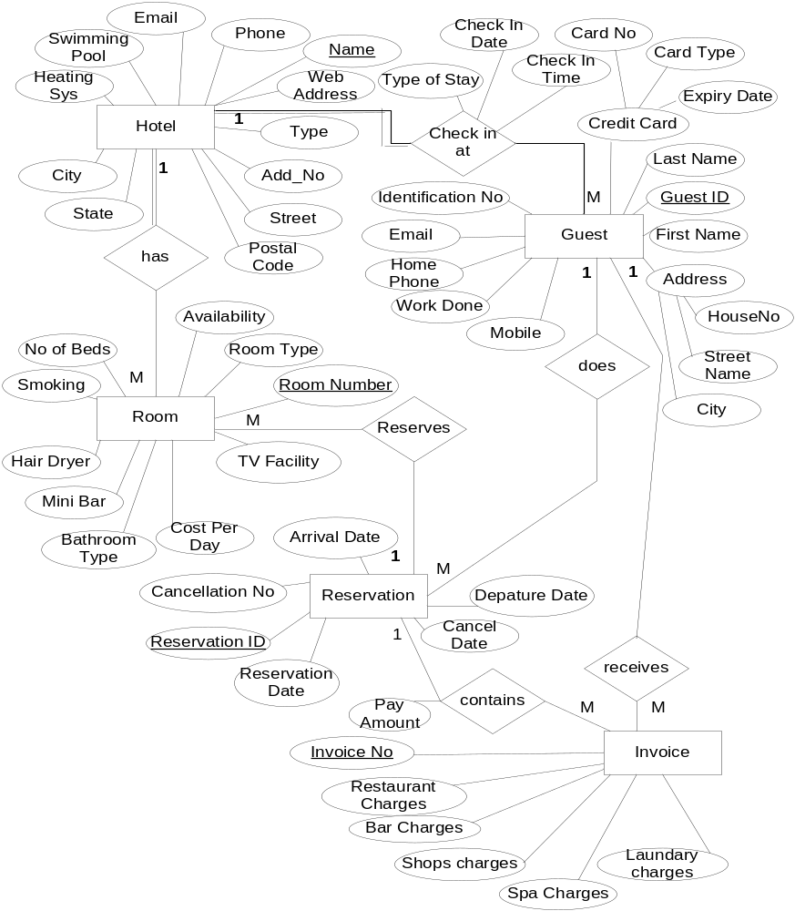

Relational Model

Relations

Hotel
{Name, Type, Add_No, Street, City, State, PostalCode, WebAddress, Phone, Email, SwimmingPool, HeatingSystem }

Guest
{GuestID, IdentificationNo, FirstName, LastName, CreditCard, Address, Mobile, WorkDone, HomePhone, Email, TypeOfStay, CheckInDate, CheckInTime, Name}

Reservation
( ReservationID, ReservationDate, ArrivalDate, DepatureDate, CancellationNo, CancelDate , GuestID)

Room
{ RoomNumber, RoomType, NoOfBeds, CostPerDay, Smoking, HairDryer, TVFAcility, IAP, MiniBar, BathroomType, Availability, Name, ReservationID}

Invoice
{InvoiceNo, RestaurantCharges, BarCharges, ShopsCharges, SpaCharges, LaundaryCharges, PayAmount, ReservationID}

1st Normalization

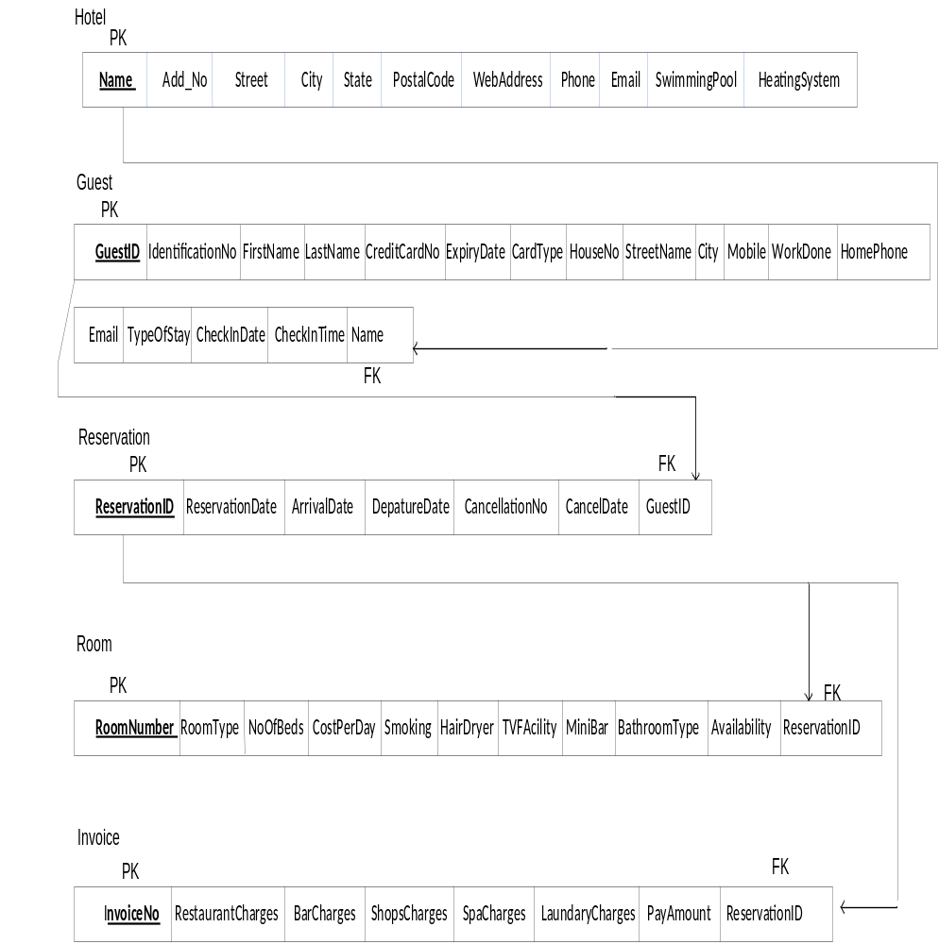

1NF Normalization

Hotel
{Name, Type, Add_No, Street, City, State, PostalCode, WebAddress, Phone, Email, SwimmingPool, HeatingSystem }

Guest
{GuestID, IdentificationNo, FirstName, LastName, CreditCardNo, ExpiryDate, CardType, HouseNo, StreetName, City, Mobile, WorkDone, HomePhone, Email, TypeOfStay, CheckInDate, CheckInTime , Name }

Reservation
( ReservationID, ReservationDate, ArrivalDate, DepatureDate, CancellationNo, CancelDate , GuestID )

Room
{ RoomNumber, RoomType, NoOfBeds, CostPerDay, Smoking, HairDryer, TVFacility, MiniBar, BathroomType, Availability , ReservationID }

Invoice
{InvoiceNo, RestaurantCharges, BarCharges, ShopsCharges, SpaCharges, LaundaryCharges, PayAmount , ReservationID }

2 NF Normalization

Any of the above relations does not have partial dependencies. No attributes can be identified by the part of the primary key. So all above relations are in 2NF.

3NF Normalization

There are no transitive dependencies in any relation. So, above relations are in the 3NF also.

Database Architecture

File Groups
In the Hotel_Reservation_System database we have added the following file groups and files.
- primary file group
primary data file (Hotelressys.mdf)

- secondary file groups
  - FGFixedData
    - Secondary data files
      - Hotelressys1.ndf
      - Hotelressys2.ndf
  - FGVariableData
    - Secondary data files
      - Hotelressys3.ndf
      - Hotelressys4.ndf

Final set of Tables
Table ID : T1
Table Name : Hotel
Table Organization : Indexed
Primary Key : Name

Field Name | Data type | Size | Description
Name | varchar | 20 | - Primary key
Add_No | varchar | 4 | - Not null
Street | varchar | 10 | - Not null
City | Varchar | 20 | - Not null
State | Varchar | 20 | - Not Null
PostalCode | Int |  | - Not null
WebAddress | Varchar | 30
Phone | Int |  | - Not null
Email | Varchar | 30 | - Not null
SwimmingPool | char | 3 | - Nullable
HeatingSystem | char | 3 | - Nullable

Reference : Appendix Table Creation

Screen Print that displays the table

Table ID : T2
Table Name : Guest
Table Organization : indexed
Primary Key : GuestID

Field Name | Data type | Size | Description
GuestID | Varchar | 5 | - Primary key
IdentificationNo | Varchar | 10 | - Not null
FirstName | varchar | 10 | - Not null
LastName | Varchar | 15 | - Not null
CreditCardNo | Varchar | 6
ExpriyDate | Date Time
CardType | Varchar | 10
HomeNo | Varchar | 5
StreetPhone | Int
City | Varchar | 10
Mobile | Int
WorkDone | Char | 3
HomePhone | Int
Email | Varchar | 20
TypeOfStay | Varchar | 10
CheckInDate | Date Time
CheckInTime | Date Time

Reference : Appendix Table Creation

Screen Print that displays the table

Table ID : T3
Table Name : Reservation
Table Organization : indexed
Primary Key : ReservationID

Field Name | Data type | Size | Description
ReservationID | varchar | 6 | - Primary key
ReservationDate | Date Time |  | - Not null
ArrivalDate | Date time |  | - Not null
DepatureDate | Date Time |  | - Not null
CancellationNo | Int
CancelDate | Date Time

Reference : Appendix Table Creation

Screen Print that displays the table

Table ID : T4
Table Name : Room
Table Organization : indexed
Primary Key : RoomNunber

Field Name | Data type | Size | Description
RoomNumber | varchar | 4 | - Primary key
RoomType | varchar | 10 | - Not null
NoOfBeds | Int
CostPerDay | Money
Smoking | Char | 1
HairDryer | Char | 1
TVFacility | Char | 1
miniBar | Char | 1
Bathroom | Char | 3
Availability | Char | 1

Reference : Appendix Table Creation

Screen Print that displays the table

Table ID : T5
Table Name : Invoice
Table Organization : indexed
Primary Key : InvoiceNo

Field Name | Data type | Size | Description
InvoiceNo | varchar | 10 | - Primary key
ResturantCharges | Money
BarCharges | Money
ShopCharges | Money
SpaCharges | Money
Laundary | Money
PayAmount | Money
ReservationID | Varchar | 6

Reference : Appendix Table Creation

Screen Print that displays the table

Specification of Stored Procedures

A stored procedure is a group of TSQL statements compiled into a single execution plan.
A stored Procedure returns data in the following ways:
1) Input Parameters – Allows an Invoker to pass a data value to the procedure.
2) Output Parameter – allows the stored procedure to pass a data value back to the invoker.
3) Return Code – allows the Stored Procedure to return an integer value to the invoker, then the stored procedure returns a default value 0 or 1, depending on the success or failure in execution.

Following are some examples of stored Procedures:

Appendix: Stored procedures

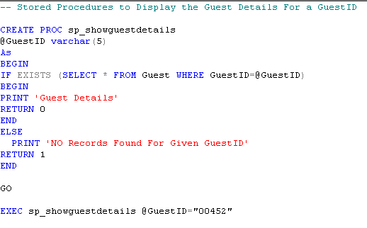

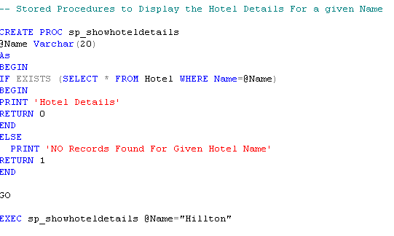

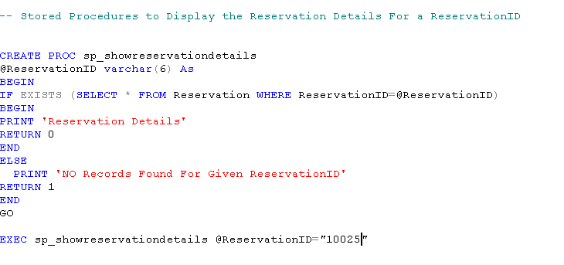

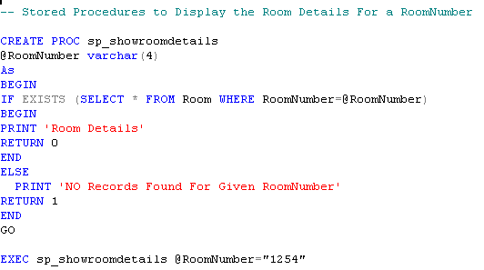

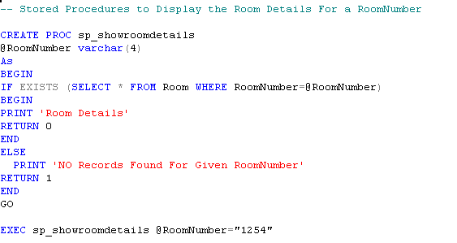

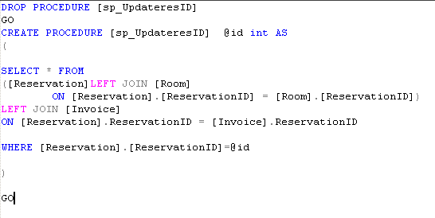

Specification of Triggers

A trigger is a type of Stored Procedure that is automatically executed in response to certain events on a particular table in a database. Triggers can restrict access to specific data.
Microsoft SQL server only supports two types of triggers which are either AFTER or INSTEAD OF even though there are many types of triggers in SQL.
A Trigger can be executed for the following types of events (actions):
- Update
- Insert
- Delete

Appendix: Triggers

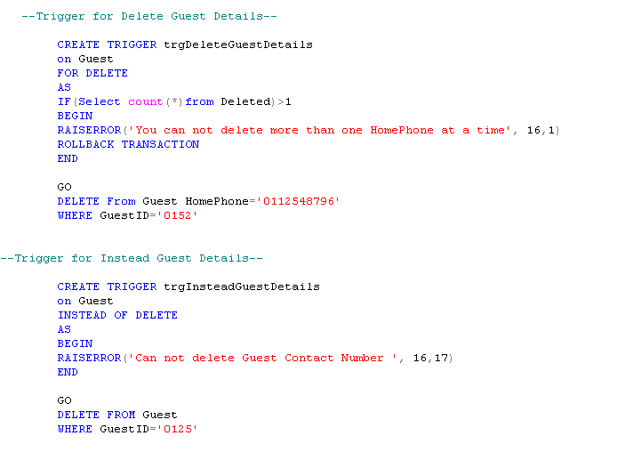

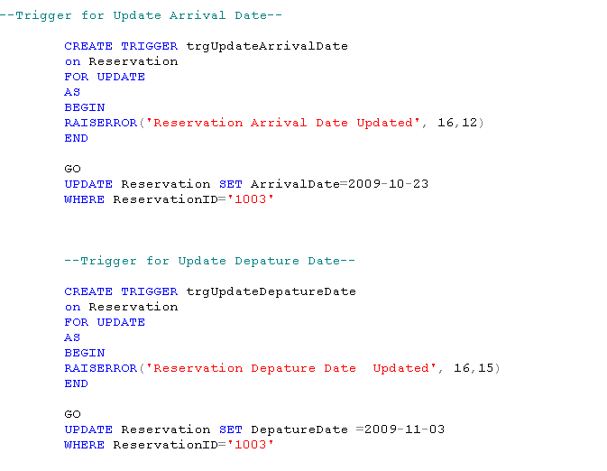
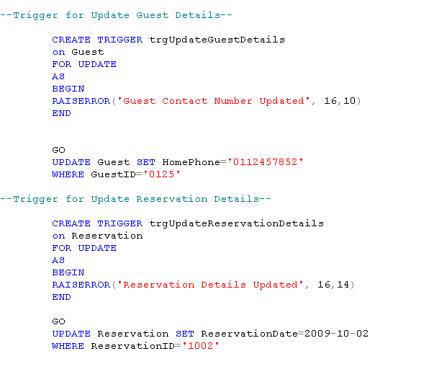

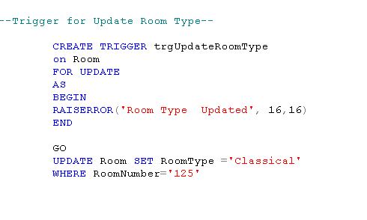

Specification of Views & Joins

Joins
A join can be defined as an operation that includes retrieval of data from more than one table at a time.

Some types of Joins
- Inner Join – displays only the values that have a match in the both joined tables.
- Outer Join- the result set of these joins contains all the rows from one table and matching rows from another.
- Left Outer Join
- Right Outer Join
- Full Outer Join

- Cross Joins – A join that includes more than one table without any condition in the ON clause. The outputs of these joints are called Cartesian Products.

Views
A view is a virtual table, which consist of a subset of columns from one or more tables.
Though it is similar to a table, it is not stored in the database. It is a query stored as an object.

Appendix Views & Joins

Specification of Built in Functions

There are various types of built in functions, following are some them.

Aggregate Functions
- COUNT – counts the number of rows in the table
- SUM – used to find the total of numeric columns
- AVG – to find the average of numeric columns
- MAX – to find the maximum value in a numeric column
- MIN – to find the maximum value in a numeric column

Datetime functions

- getDate()
- dateDiff()
- dateName()
- datePart()
- dateAdd()

Appendix Built in Functions

Security Plan

When a user connects with a specified login name and password from a nontrusted connection, SQL Server performs the authentication itself by checking to see if a SQL Server login account has been set up and if the specified password matches the one previously recorded. If SQL Server does not have a login account set, authentication fails and the user receives an error message.
SQL Server Authentication is provided for backward compatibility because applications written for SQL Server version 7.0 or earlier may require the use of SQL Server logins and passwords. Additionally, SQL Server Authentication is required when an instance of SQL Server is running on Windows 98 because Windows Authentication Mode is not supported on Windows 98. Therefore, SQL Server uses Mixed Mode when running on Windows 98 (but supports only SQL Server Authentication).
Application developers and database users may prefer SQL Server Authentication because they are familiar with the login and password functionality. SQL Server Authentication may also be required for connections with clients other than Windows NT 4.0 and Windows 2000 clients.

Appendix: Database access Logins

Appendix: Role Member

Appendix Database Creation

